[YOUR PROJECT NAME]
Use Case Specification

Submitted to:

Asst. Prof. Ma. Rowena C. Solamo
Faculty Member
Department of Computer Science
College of Engineering
University of the Philippines, Diliman

Submitted by:
[List of Members in Alphabetical Order]

In partial fulfillment of academic requirements
for the course
CS 191 Software Engineering I
of the
1st Semester, AY <YYYY-YYYY>
Unique Reference:
The documents are stored in the [GitHub Repository Link].
[File Reference in GitHub, preferably link.]

Document Purpose:
[What is the purpose of the document?]

Target Audience:
[Place here the target audience.]

Revision Control

History Revision:
Revision Date | Person Responsible | Version  Number | Modification
MM/DD/YY | Juan de la Cruz | 1.0 | Initial Document; Version number should match the one found in the footer.

Use-Case Name: [Name of Use Case: eg. 1.0 Applicant is assigned to a squad.]

Description: [Write the 3 to 5 sentences that describes the Use Case.]

Preconditions: [If there are any, write the preconditions. Otherwise, simply type NONE.]

Flow of Events:
Scenario Name | Description
Scenario 1 (Basic Flow)  Applicant is assigned to the training squad. | 1. Selection committee gets application form.  2. Club staff prepares try-out area.  3. Selection committee evaluates applicant's performance in mock try-outs.  4. If applicant needs training, he is assigned to the training squad.  5. Club staff keeps the application forms in the appropriate files.
Scenario 2  Applicant is assigned to the competing squad. | 1. Selection committee gets application form.  2. Club staff prepares try-out area.  3. Selection committee evaluates applicant's performance in mock try-outs.  4. If applicant plays excellent, he is assigned to the competing squad.  5. Club staff keeps the application forms in the appropriate files.

Activity Diagram of the Flow of Events:
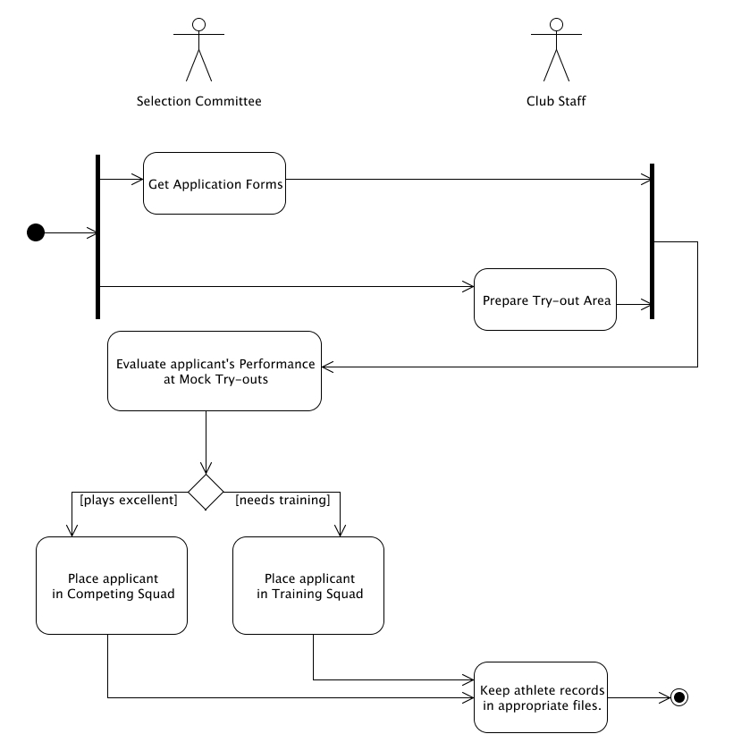

Place here the activity diagram. Make sure that the diagram is grouped as one and text does not wrap around the diagram.

Postcondition: [If there are any, write them here. Otherwise, type in NONE.]

Relationships: [If there are any, write them here. Otherwise, type in NONE.]

Special Requirements:
[If there are any, write them here. Otherwise, type in NONE.]

